Database management with SQLite

Database Management Systems

1. Database Schema

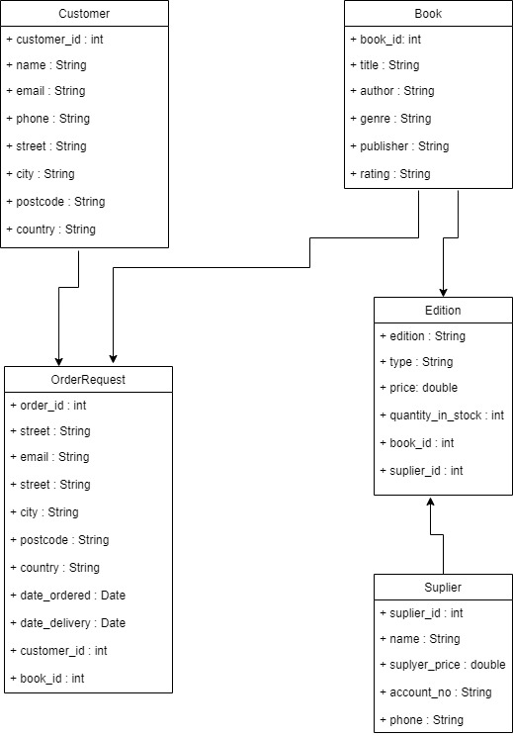

1. SQLite database

Here we are creating the SQLite database

create table Customer(

customer_id number primary key,

name varchar(20),

email varchar(20),

phone varchar(12),

street varchar(20),

city varchar(20),

postcode varchar(6),

country varchar(20)

);

In this Customer table customer_id is **primary key**.

create table Book(

book_id number primary key,

title varchar(20),

author varchar(20),

genre varchar(20),

publisher varchar(20),

rating varchar(20)

);

In this Book table book_id is **primary key**.

create table OrderRequest(

order_id number primary key,

street varchar(20),

city varchar(20),

postcode varchar(6),

country varchar(20),

date_ordered date,

date_delivered date,

customer_id number,

book_id number,

FOREIGN KEY (customer_id) REFERENCES Customer(customer_id),

FOREIGN KEY (book_id) REFERENCES Book(book_id)

);

In this OrderRequest table order_id is **primary key** and customer_id, book_id are **Foreign Key**.

create table Suplier(

suplier_id number primary key,

name varchar(20),

supplyer_price number,

account_no varchar(20),

phone varchar(12)

);

In this Suplier table suplier_id is **primary key** .

create table Edition(

edition varchar(20),

type varchar(20),

price number,

quantity_in_stock number,

book_id number,

suplier_id number,

FOREIGN KEY (suplier_id) REFERENCES Suplier(suplier_id),

FOREIGN KEY (book_id) REFERENCES Book(book_id)

);

In this Edition table suplier_id, book_id are **Foreign Key**.

inserts data into tables

1. insert data into Suplier table.

insert into Suplier values (300,'aditya',280,'899899000','9098789098');

insert into Suplier values (301,'aditya',280,'899899000','9098789098');

insert into Suplier values (302,'aditya',280,'899899000','9098789098');

insert into Suplier values (303,'aditya',280,'899899000','9098789098');

insert into Suplier values (304,'aditya',280,'899899000','9098789098');

insert into Suplier values (305,'aditya',280,'899899000','9098789098');

insert into Suplier values (306,'aditya',280,'899899000','9098789098');

1. insert data into Suplier table.

insert into Customer values (1,'raj','abc@gmail.com','9090987656','sheohar','sheohar','843334','india');

insert into Customer values ( 2,'raju','abc@gmail.com','9090987656','sheohar','sheohar','843334','india');

insert into Customer values ( 3,'ram','abc@gmail.com','9090987656','sheohar','sheohar','843334','india');

insert into Customer values ( 4,'raman','abc@gmail.com','9090987656','sheohar','sheohar','843334','india' );

insert into Customer values ( 5,'shayam','abc@gmail.com','9090987656','sheohar','sheohar','843334','india' );

1. insert data into OrderRequest table.

insert into OrderRequest values (200,'sas','raipur','898767','india','jan 1 2009','jan 1 2009',1,100);

insert into OrderRequest values (201,'sas','raipur','898767','india','jan 1 2020','jan 5 2020',2,101);

insert into OrderRequest values (202,'sas','raipur','898767','india','may 1 2020','may 5 2020',3,102);

insert into OrderRequest values (203,'sas','raipur','898767','india','april 1 2020','april 6 2020',4,103);

insert into OrderRequest values (204,'sas','raipur','898767','india','feb 5 2020','feb 10 2020',5,104);

insert into OrderRequest values (205,'sas','raipur','898767','india','jan 10 2020','jan 15 2020',6,105);

1. insert data into Book table.

insert into Book values (100,'math','r.s.aggarwal','Science and Technology','Ultimate Books','4');

insert into Book values (101,'physics','gosdd','Science and Technology','Ultimate Books','4');

insert into Book values (102,'c','hsdf','Science and Technology','Ultimate Books','4');

insert into Book values (103,'chemistry','r.s.aggarwal','Science and Technology','Ultimate Books','4');

insert into Book values (104,'cpp','raman','Science and Technology','Ultimate Books','4');

insert into Book values (105,'java','gosling','Science and Technology','Ultimate Books','4');

1. insert data into Book table.

insert into Edition values ('2005','math',304,10,100,300);

insert into Edition values ('2004','physics',35,10,101,301);

insert into Edition values ('2005','chemistry',304,14,102,302);

insert into Edition values ('2003','c',302,5,103,303);

insert into Edition values ('2005','cpp',354,4,104,304);

insert into Edition values ('2008','java',234,10,105,305);

1. SQL Data Manipulation

1. List all books published by “Ultimate Books” which are in the “Science and Technology” genre;

Query:- select * from book where publisher='Ultimate Books' AND genre='Science and Technology';

2. List all orders placed by customers with addresses in the city of Edinburgh, since 2016, in order of date, latest first;

Query:- select * from customer where city='Edinburgh' AND customer_id in (select customer_id from OrderRequest where date_ordered>=2016);

3. List all book editions which have less than 5 items in stock, together with the name, account number and supply price of the minimum priced supplier for that edition.

Query:- select edition,name,supplyer_price,account_no from Suplier INNER JOIN Edition Where Suplier.suplier_id=Edition.suplier_id;